**Places to go this Summer…** 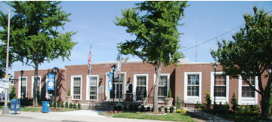

**HEMPSTEAD,NY**

**Parks and Recreation**

<http://www.villageofhempstead.org/directory.asp?submit=Y>

* **Brierley Park Community Center**  
  Clinton and Dartmouth Streets  
  **Phone:**  489-3400  
  Athletic fields, basketball courts, children's play area, weight lifting
* **Harold Mason, Jr. Memorial Playground**  
  Washington Street (at Jackson Street)
* **Hempstead Recreation Department**  
  335 Greenwich Street  
  *George Sandas, Superintendent of Parks***Phone:**  489-3400 x 247
* **Kennedy Memorial Park**  
  335 Greenwich Street  
  **Phone:**  489-3400  
  Athletic fields, tennis courts, children's play area, indoor aerobics & basketball facilities, pool, and arboretum walking path
* **Lincoln Park**  
  South Franklin Street and Graham Avenue  
  **Phone:**  489-3400  
  Pool, children's play area, lighted basketball court, astro-turf football/soccer field
* **Mirschel Park**  
  90 Atlantic Avenue  
  **Phone:**  489-3400  
  Athletic field, children's play area, basketball courts
* **Town of Hempstead Department of Parks and Recreation**  
  200 North Franklin Street, Second Floor  
  *Joseph Bentivegna, Commissioner***Phone:**  292-9000  
  Administers facilities throughout the Township

**Town of Hempstead POOLS:**

East Meadow, Elmont, Bellmore, Oceanside- Link has hours and rates

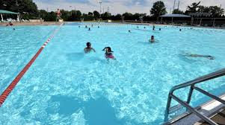

<http://www.toh.li/facilities/beaches-and-pools/outdoor-pools>

**Town of Hempstead PARKS:**

This link shows all of the available parks to go visit, what it offers and where to find it.

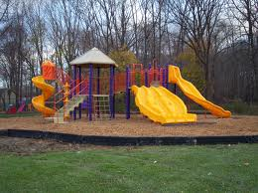

<http://www.toh.li/facilities/parks>

* **Smith Street Park** – Uniondale= 483-2770

Offers….Basketball, Handball, Paddleball, Spray Pool, Baseball, Softball, Playground, Play Equipment, Sitting Area

**Town of Hempstead ACTIVITIES:**

This link shows all of the activities offered by the town of Hempstead.

*Aquatics, Athletics, Physical Fitness, Triathlons, Children’s Activities, Cultural Events, etc.*

<http://www.toh.li/activities/athletics>

**SUMMER DAY CAMP:**

***Family & Children’s***

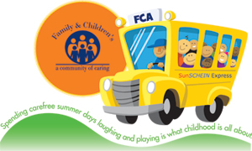Family & Children’s offers a warm and enriching summer camp experience to children 5 to 15 years of age. Our camp is located at our Hagedorn Family Resource Center in Hempstead and is open to families in neighboring communities.  Summer of Promise activities are offered in the areas of **literacy, art and science to reduce summer learning loss. Great trips and physical activities enhance the experience for youth.**

* **Contact:**Donna W. Raphaël, MA 516-486-7690 x1 or Spanish x2 or [DWRaphael@familyandchildrens.org](mailto:DWRaphael@familyandchildren.org)

**** No transportation provided, parents responsible for drop-off and pick-up

**Donna W. Raphaël, MA, Director of Youth Services & Community Relations**  
*Phone:*(516) 486-7690 x1 or Spanish x2   
*Email:*[DWRaphael@familyandchildrens.org](mailto:DWRaphael@familyandchildren.org) 

**ADDITIONAL SERVICES:**

* **Boys and Girls Club**  
  **Administrative Office**  
  40 Washington Street  
  Hempstead, NY 11550  
  **Executive Director:**Wayne K. Redman  
  (516) 292-3447  
  **Website:** [www.hbgclub.com](http://www.hbgclub.com/)  
  **Ages:** Youth

**Service Locations include:**                                                               
**Methodist Teen Center**   
40 Washington Street, Hempstead, NY 11550.   
516-292-3520    
Hours 3:00pm-7:00pm Mon-Fri.

**Fulton Elementary School**40 Fulton Street Hempstead, NY 11550.  
516-292-111 Ext. 4200   
Hours 3:00pm-7:00 pm Mon-Fri.

**Franklin Elementary School**335 South Franklin Street, Hempstead, NY 11550.    
516-292-7111 Ext. 4127   
Hours 3:00pm-7:00pm Mon-Fri.

**Services Offered:**

-Sports Fitness Recreation

-Technology Instruction

-Character and Leadership Development

* **Hempstead P.A.L.**  
  295b South Franklin Street   
  Hempstead, NY 11550  
  **Director:**Det. Jackie Jones-Ford  
  (516) 485-2180  
  **Website:** [www.jackiehempsteadpal.com](http://www.jackiehempsteadpal.com/)    
  **Ages:** 5 to 18

**Programs Include:**

* The P.A.L. currently offers to boys and girls for a small registration fee,
* **Dance** (Tap, Jazz, Hip Hop, Modern, Ethnic, Point, Ballet) for ages 5 to 18, September to June
* **Kung Fu for ages 5** and up, year round.
* Cheerleading ages 7 to 15, October to February.
* Golf ages 8 to 14, June to July.
* **Karate ages** 5 to 18, year round.
* Junior and Biddy Basketball ages 7 to 12, October to February.
* Travel Basketball ages 7 to 12. December to August.
* Senior Basketball ages 13 to 16, April to June.
* Bowling ages 6 and up, year round.
* Track and Field ages 6 and up. Early April.
* Travel League Track and Field ages 6 to 18, late July.
* **Percy Jackson Memorial Youth Center, Inc.**  
  436 South Franklin Street   
  Hempstead, NY 11550  
  **Director:**Andre Huff  
  (516) 486-3661   
  **Website:**  None  
  **Ages:** Youth

**Programs Include:**

* Gym programs
* Arts and crafts programs
* Courses for college SAT and Civil Service examination preparation
* Job placement services
* Health and hygiene courses
* **Salvation Army Community Center**  
  65 Atlantic Avenue  
  Hempstead, NY 11550   
  **Corps Commander:** Major and Mrs. Steven Ditmer  
  (516) 485-4900  
  **Website:** None  
  **Ages:** 6 to 25

**Programs Include:**

* Basketball, volleyball, table games
* Dance classes
* Computer instruction classes
* Tutorial sessions